BIOC 455
Lecture # 18– Endocannabinoids
Lecturer: Dr. S. Williams – February 14th, 2007

NOTE: This NTC is meant to be used as a study aid to supplement your own class notes. Hence, not all of the text or diagrams contained in the lecture slides will be reproduced here.

Please send any comments or questions about NTCs to either Wanda or James through e-mail at u3.represent@gmail.com .

Announcements:
First thing to remember is that the midterm will begin at 8 am, on Monday, February 26. The only reason for this is to give an extra 30 minutes for the exam. The material on the exam will cover from the beginning of the semester up to and including Monday February 12, the lecture on Alzheimer’s disease. This includes the two lectures on the readings. The questions on the readings will most likely be in short hand written answer format.
The exam will consist of 2/3 multiple choice and 1/3 written answer.
The second thing: Please select your topic for the term paper. You must email the professor of the paper you choose for your term paper. Please pick your topic as soon as you can.

About the Class on Alzheimer’s disease:

This lecture was a condensed 3-hour class. His point of the lecture was to be a primer class with highlights of the research and main ideas of Alzheimer’s disease today. The question what about acetylcholine in Alzheimer’s disease? The class was on the historical grounds and then the question at the end of the lecture was about acetylcholine and Alzheimer’s disease. This was to ask for main points. Is acetylcholine vital for Alzheimer’s disease? This is a grey area. He was clear last class. Acetylcholine neurons and basal forebrain are affected by this disease. This was the first hard evidence proven in this disease.

The second point was that 25 years later pharmacologically there are only cholinergic esterase inhibitors approved. These drugs are trying to increase the amount of acetylcholine in the synaptic cleft. Also these drugs have a weak effect on the symptoms of the disease and the disease. Cholinergic neurons are affected early in the progress of Alzheimer’s disease. This is not the crucial link in the disease. It is associated to the disease because if you increase acetylcholine you slow down the symptoms of the disease.

Question: “Most of the drugs to treat Alzheimer’s disease were AMPA agonist and were used to treat memory impairment. What can you say about that?”

There are no drugs approved for the AMPA receptor. There are currently molecules called Ampakines that are in clinical trials. These molecules increase the open time for the AMPA receptor. This allows for more sodium to flow through into the post synaptic neuron causing it to fire more readily. The molecules were developed by a professor in California, Garylin? There are none approved now but maybe in the next few years.

There is a NMDA receptor antagonist, Manatene, approved 2 years ago by the FDA for the treatment of late stage Alzheimer’s disease. It is paradoxal to give a NMDA antagonist, although it could be used to lower the inflammation or the cytotoxicity in the brain. This is usually given in the late stages of the disease and there is little benefit seen after given this. PCP is another NMDA antagonist. The prescription of Manatene is usually with a cocktail of other drugs like antipsychotics, to prevent the hallucinations, and acetylcholine esterase inhibitors.
There are positive clinical trials ongoing. A Montreal Biotech company, Neurochem, has phase 2 clinical trials for a drug that decreases the fibrillation of β amyloid. Phase 2 clinical trials are where they determine the toxicity of the drug. The results are very positive 1500 patients to see if it works. See results next year.

Complicated disease and not simple… there are positive in transgenic mice. All pharmaceuticals and other research at university for AD are using transgenic mice that over express APT the precursor or mutated prostanilin genes that produces components of the gamma secretase. These TG mice resembles the AD in humans. Used in study and good candidates for future human trials.

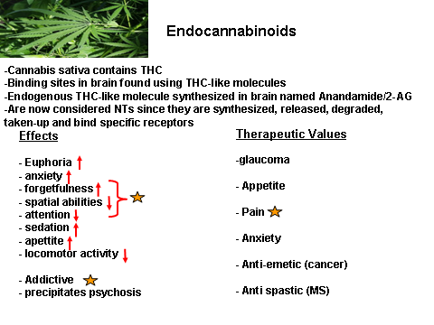
Today’s Lecture:
The active component of marijuana is THC, tetra-9-hydro-cannabinol. THC is effective in decreasing anxiety and useful as an anti-emetic, (reduction of vomiting). In studying the brain, types of receptors on neurons can bind to THC like molecules. These receptors are the cannibinoid receptor. Endogenous cannabinoids were then found that bound to this receptor. Two of these endocannabinoids are Anandamide and 2-Arachidonoylglycerol, 2-AG. These endocannabinoids are considered to be neurotransmitter because they are synthesized, released, degraded taken and bind specific receptors.

The effects of the neurotransmitter can be seen on slide 1. He went through the list and highlighted that endocannabinoids are starred. The therapeutic values of these NT are that it has been known to treat Glaucoma, relieve the pressure in the eye, as an anti-emetic in chemotherapy and be anti-spastic in MS. There is a focus in studying endocannabinoids for their potential of increasing appetite in cancer patients but the focus has been on treating pain.
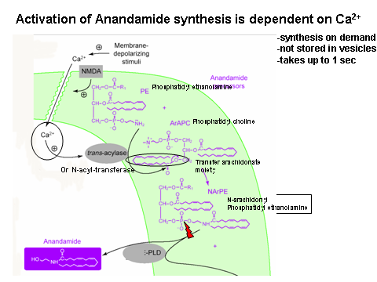
Slide 2: Anandamide concentrations in the brain

This imaging study was done in a rat brain, this is similar to humans. The highest concentrations are in red, green, and yellow. The weaker concentrations are in purple. There are high amount of Anandamide in the striatum region of the Nucleus Acumens. The Nucleus Acumens is associated with addiction and learning associated with addiction. There are high concentrations in the cortex and the septum is the cholinergic system. The hippocampus also contains a lot of Anandamide. There is a lot of modulating in the hippocampus. AM404 is a specific blocker of the Anandamide transporter.

Slide 3: Synthesis of Anandamide in brain.

Phosphatidyl choline reacts with phosphatidyl ethanolamine through the enzyme NAT, N-acyl-transferase or Trans-acylase. The product is then hydolysized by PLD, Phospholipase-D into the final product of Anandamide. It is important to remember the enzymes involved not the organic chemistry.

Slide 4: Activation of Anandamide synthesis is dependent on Ca²⁺

Anandamide is not stored in vesicles. It is synthesized on demand, which is specific to endocannabinoids. When Ca²⁺ enters the neuron the process begins. It can take up to 1 sec for the synthesis to be completed, which is a slow process. This process can occur anywhere in the neuron. In active neurons there will be increased production because there will be more calcium in those neurons.

Slide 5: Synthesis of 2-Arachidonylglycerol (2-AG)

There are 2 precurser molecules. Once again the focus is on the enzymes. Phosphatidylinositol biphosphate is hydrolysized by PLC. Then DAG is acted on by DAGL which is a lipase producing 2-AG. Slide 6 is just showing that 2-AG is dependent on calcium too. Metabotropic glutamate receptors activation also can activate PLC and cause 2-AG to be produced.

Slide 7: Breakdown of 2-Ag and Anandamide

Once again you have to know the enzymes involved. FAAH, Fatty Acid Amide Hydrolase, breaks down Anandamide into arachidonic acid and ethanolamine. MAGL, Monoacyl clycerol lipase, breaks down into other substances such as glycerol and arachidonic acid.

Slide 8: There is a carrier molecule that transports endocannabinoids in and out of the cell. This is a high affinity pump. There are no vesicles! The Am404 are a specific blocker of the pump. The same pump is responsible for reuptake of the neurons. The cannibinoid receptor can be found pre and post synaptically.

Slide 9: Review:

Endocannabinoids are synthesized on demand. The more active the cell is the more calcium there is in the cell allowing for more production of the NT. The NTs are not stored in vesicles and are released by a pump. It is believed that the same pump uptakes the NT. The action of endocannabinoids is slow because they need to be synthesized and released by a pump. They can diffuse away for several 10’s of um. This allows modulation of cells around the neuron and not specific to the synaptic cleft. They are usually degraded presynaptically but can be degraded post synaptically too.

Slide 10: Hippocampus and learning and memory.

There are hundreds of thousands of pyramidal neurons in the single layer of the hippocampus. This is very different from the cortex which consists of many layers. There are very few GABA neurons in the hippocampus but have lots of synaptics on the pyramidal neurons. If you zoom in on the layer, you see the pyramidal neurons and see lots of CB1 receptors on and around the synapses. The receptor is essentially presynaptic.

Slide 11: CB1 activates

There are two types of receptor, the main one in the brain is CB1. It activates the Gi/Go G protein. This will cause an increase of the K+ conductance. This receptor is on the presynapse. This increases the K permeability and which causes the hyperpolarization. There will be a decrease in NT release and activity of the neuron. This is a kind of a negative feedback mechanism.

Slide 12: Endocannabinoids mediate presynaptoc modulation of glutamate and GABA in hippocampus Effects on Memory

Cannabinoids can modulate memory. All the excitatory and inhibitory neurons in the hippocampus will be inhibited. There are DSE, depolarization induced suppression of excitation and DSI, depolarization induced suppression of inhibition. DSE acts on excitatory neurons like glutamate and DSI acts on GABA neurons. The inhibition breaks the balance on inhibition and excitation that is required for learning and memory.

Slide 13: How is DSI experimentally tested?

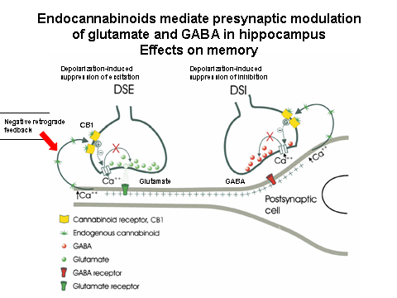
This is tested using whole cell recording on the pyramidal cells. The inhibition post synaptic current, IPSC, measured the GABA induced potential is around -500 pA. This affect and can be inhibited when a postsynaptic cell is excited causing endocannabinoids to be produced and feed back inhibiting the release of GABA lowering the current. This can be said to be an endocannabinoid because when inhibited by the AM 251, a cannibinoid transporter inhibitor, there is no inhibition.

Slide 14: And on DSE

The negative feed back is seen here too. It is instead of GABA and excitatory neuron is used instead.

Slide 15: Role of CB1 in nociception
There are many pharmaceuticals looking at this cannabinoids to reduce pain. On the synaptic terminal of pain receptors have CB1 receptors presynaptically. Postsynaptic neurons can produce cannabinoids that will reduce the presynaptic release of glutamate in this example or reducing the sensory input therefore reducing the pain.

Slide 16: Summary of physiological roles for endocannabinoids

Slide 17: What to remember!
- The enzymes involved in the synthesis and breakdown of Anandamide and 2-AG
- The association between calcium and the production of endocannabinoids
- The signaling pathways of CB1 receptors
- Their role in pain, in learning and memory
- Glutamate and GABA modulation through the suppression of release

